____________________________

Operation Manual

VEUDx Experiment Editor

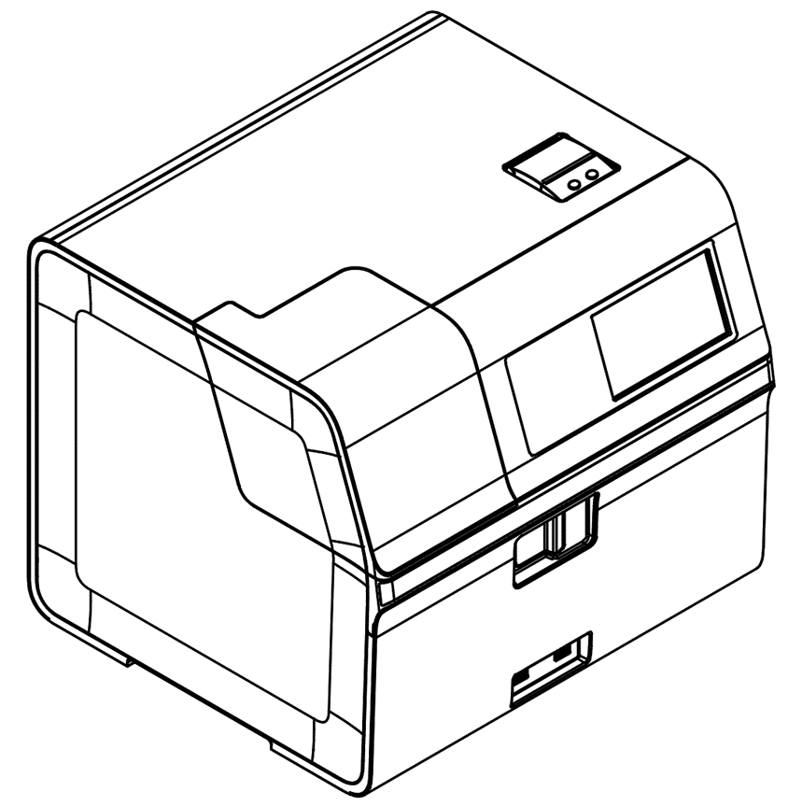

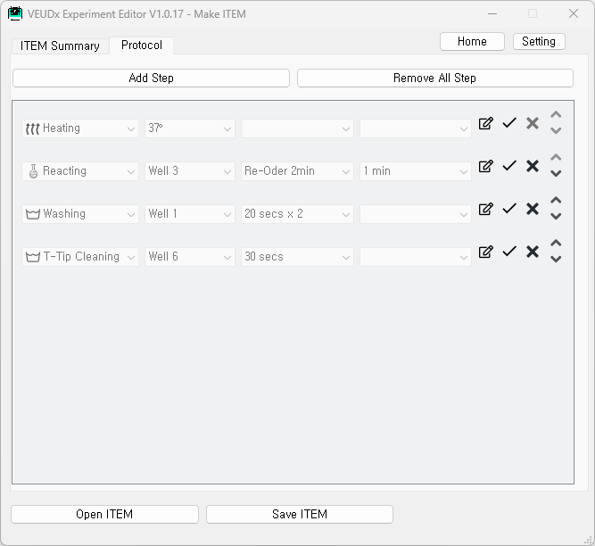

UM-VEUDx-1.0

**User Manual History**

|  |  |  |
| --- | --- | --- |
| Rev. No. | Date | Major Change |
| 1 | 2022.11.15 | Initial Version |
| 2 | 2022.12.06 | Editing Step UI change |
| 3 |  |  |
| 4 |  |  |
| 5 |  |  |
| 6 |  |  |

Index

1. Installation 4

2. Term definition 6

2.1 ITEM 6

2.2 LOT 6

3. Start 7

3.1 Start screen 7

4. Make ITEM 7

4.1 ITEM creation start screen 7

4.2 Edit ITEM Summary 8

4.3 Edit Protocol 9

4.4 Save ITEM and Installation 10

5. Make LOT 11

5.1 Select ITEM file 11

5.2 Make LOT 11

6. Settings 13

6.1 Open Settings 13

6.2 Unit 14

6.3 Development menu 14

# 

# 1. Installation

|  |  |
| --- | --- |
|  | 1.1 Installation |
| 1.1.1 Execution | Execute VEUDx Experiment Editor Setup V1.x.x.exe on PC. |
| **1.1.2 Language selection** | Choose the language you want to use |
| 1.1.3 Start installation | Check the contents and click ‘Next’. |
| 1.1.4 Check License | Read the license agreement and click ‘I Agree’. |
| 1.1.5 Installation location | Check the installation path and click ‘Install’. |
| 1.1.6 Installation  completion | Check to run the program and click ‘Finish’. |

# 

# 2. Term definition

|  |  |
| --- | --- |
|  | 2.1 ITEM |
| 2.1.1 ITEM | ITEM consists of ITEM name( ex) TBI, Neurology ), Marker name, Pixel Cut, Experiment Protocol, etc. |
| 2.1.2 Protocol | Protocol is a collection of experimental procedures (Steps). |
| 2.1.3 Step | This is the procedure for each well. (ex) Well 6 Washing 1 min ) |
| 2.1.3 ITEM file | ITEM File is created as VEUDxITEM_ITEM_name.zip file.  (ex, VEUDxITEM_TBI.zip ) |
|  | 2.2 LOT |
| 2.1.1 LOT | Depending on the produced LOT, it consists of calibration, concentration cut-off value, etc. An ITEM file is required to create a LOT. |
| 2.1.2 LOT file | A LOT XML file that stores LOT information and a Barcode PDF file are created.  Ex)  VEUDxLOT_TBI_EZTB22111601.xml  VEUDxLOT_TBI_EZTB22111601_BarCode.pdf |

# 3. Start

|  |  |
| --- | --- |
|  | 3.1 Start screen |
| **3.1.1 Start screen** | On the start screen, you can select ‘Make ITEM’, ‘Make LOT’, or  ‘SW Manual’. |

# 4. Make ITEM

|  |  |
| --- | --- |
|  | 4.1 ITEM creation start screen |
| 4.1.1 Start screen | ITEM Open, save and edit are possible.  - In the ITEM Summary tab, you can edit the item name, maker name by RSMP length, unit, pixel cut, experiment time, Dilution Factor, Fluorescence Exposure Time, Optical photography only, etc.  - You can edit steps in the Protocol tab. |
|  |  |
|  | 4.2 Edit ITEM Summary |
| 4.2.1 Open ITEM | Press the “Open ITEM” button to select the previously created ITEM file.  ITEM files are in *.zip. (ex, VEUDxITEM_TBI.zip ) |
|  |  |
| 4.2.2 Edit ITEM  Summary | - Item name  - Marker name used by RSMP length  - Unit used by RSMP length  - Total experiment time  - Pixel Cut Bottom, Top  - Dilution Factor  - Fluorescence Exposure Time  Editable.  - If “Optical photography only” is selected, only optical photography  is performed for the cartridge that has been tested. |
|  |  |

|  |  |
| --- | --- |
|  | 4.3 Edit Protocol |
| 4.3.1 Protocol tab | If you select the Protocol tab, you can edit the Step. |
|  |  |
| 4.3.2 Add Step | Click the “Add Step” box at the top and add an item.    - Selection by Category  .Heating : 30°/ 35° / 37° / 38° / 39° / X / RT selectable  .Reacting : Reaction Well (Well 2~5) selectable  - Re-Order 2min (Change the location of RSMP every 2 minutes.)  -> 1~30 min selectable  - Re-Order 5min (Change the location of RSMP every 5 minutes.)  -> 1~480 min selectable  .Washing: Well1~7 and time (20 secsX2, 30 secsX2) selectable  .T-Tip Cleaning: Well1~7 and time (30 secs) selectable   |  |  | | --- | --- | |  | Heating can be selected only once and must be located only in the first step. | |
| * + 1. Edit Step | -  : Change edit Step mode  -  : Save Step  -  : Delete Step  - : Change Step Order |
|  |  |
|  | 4.4 Save ITEM and Installation |
| 4.4.1 Save ITEM to PC | Click the “Save ITEM” button to create an ITEM zip file.  *For how to save only protocol (script) for development reference, refer to the setting section. |
|  |  |
| 4.4.2 ITEM  installation  on VEUDx  equipment | 1. Copy the ITEM file created above to an external USB memory  2. Run VEUDx equipment  3. Admin Login (Initial Admin Password: 0000)  4. Click Settings  5. Click Information  6. Click Item  7. Mounting on an external USB memory device  8. Select Update    9. Select ITEM to update  10. ITEM update complete  11. Restart after shutting down the equipment |

# 5. Make LOT

|  |  |
| --- | --- |
|  | 5.1 Select ITEM file |
| 5.1.1 Select  ITEM file | Select ITEM file to make LOT. |
|  |  |
|  | 5.2 Make LOT |
| 5.2.1 Start | The ITEM name and Marker name read from the ITEM file are displayed. |
|  |  |
| 5.2.2 Enter LOT  information | - Cal Value (a, b, c, d)  - LOT creation date  - LOT Serial  - LOT Expire Date can be entered.  *Barcode Name, Note can be used as a reference. |
|  |  |
| 5.2.3 Save LOT | Click the “Save LOT(+PDF)” button  Two LOT XML files and Barcode PDF files are created.  - LOT XML file (ex, VEUDxLOT_TBI_EZTB22111601.xml) Used to save work  When using VEUDx equipment, it can be used when there is no Barcode Reader equipment.    - Barcode PDF file (ex, VEUDxLOT_TBI_EZTB22111601_BarCode.pdf)  It is used for reading VEUDx equipment LOT/Scrip Barcode by printing it out on paper.    < VEUDx equipment LOT reading screen >    < PDF file for LOT Barcode output > |
| 5.2.4 Open LOT | Editing is possible by selecting the saved LOT XML by pressing the “Open LOT” button. |

# 6. Settings

|  |  |
| --- | --- |
|  | 6.1 Open Settings |
| 6.1.1 Open  Settings | ‘Press the ‘Settings’ button. |
|  | 6.2 Unit |
| 6.2.1 Unit | Units to be displayed in the Unit Combo List of the ITEM Summary tab can be edited. |
|  |  |
|  | 6.3 Development menu |
| 6.3.1 Development  menu | If you select the development menu, you can open/save only the protocol and display comments for analysis. |
| 6.4.2 Save  protocol file | If you press the ‘Save Protocol’ button, only the Protocol (Script) file can be saved separately.  This is a development file and cannot be installed on a machine.  When “Add Comment”, comments are displayed on the Protocol (Script).  < Protocol display according to annotation options > |